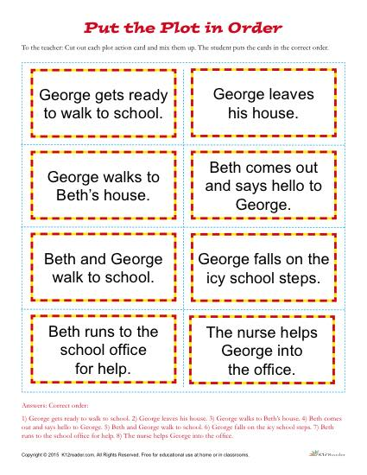The story below is in the correct sequence, so trainers need to cut each part and put them in disorder before handing them to the students.